Joins two shortest words

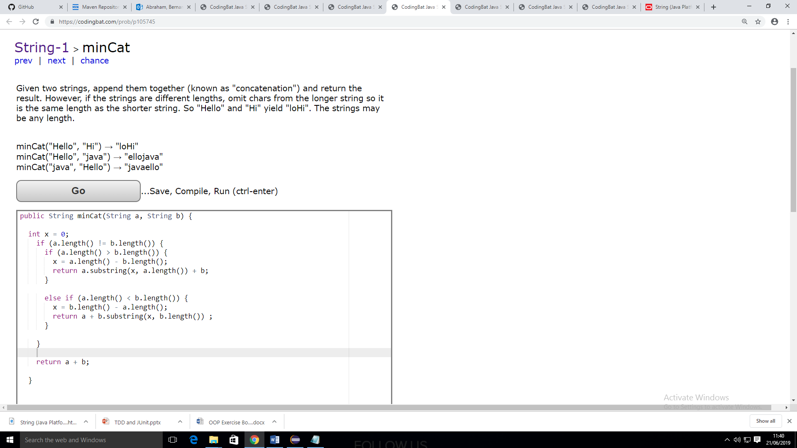

Concatenates two strings removing duplicate joining letters

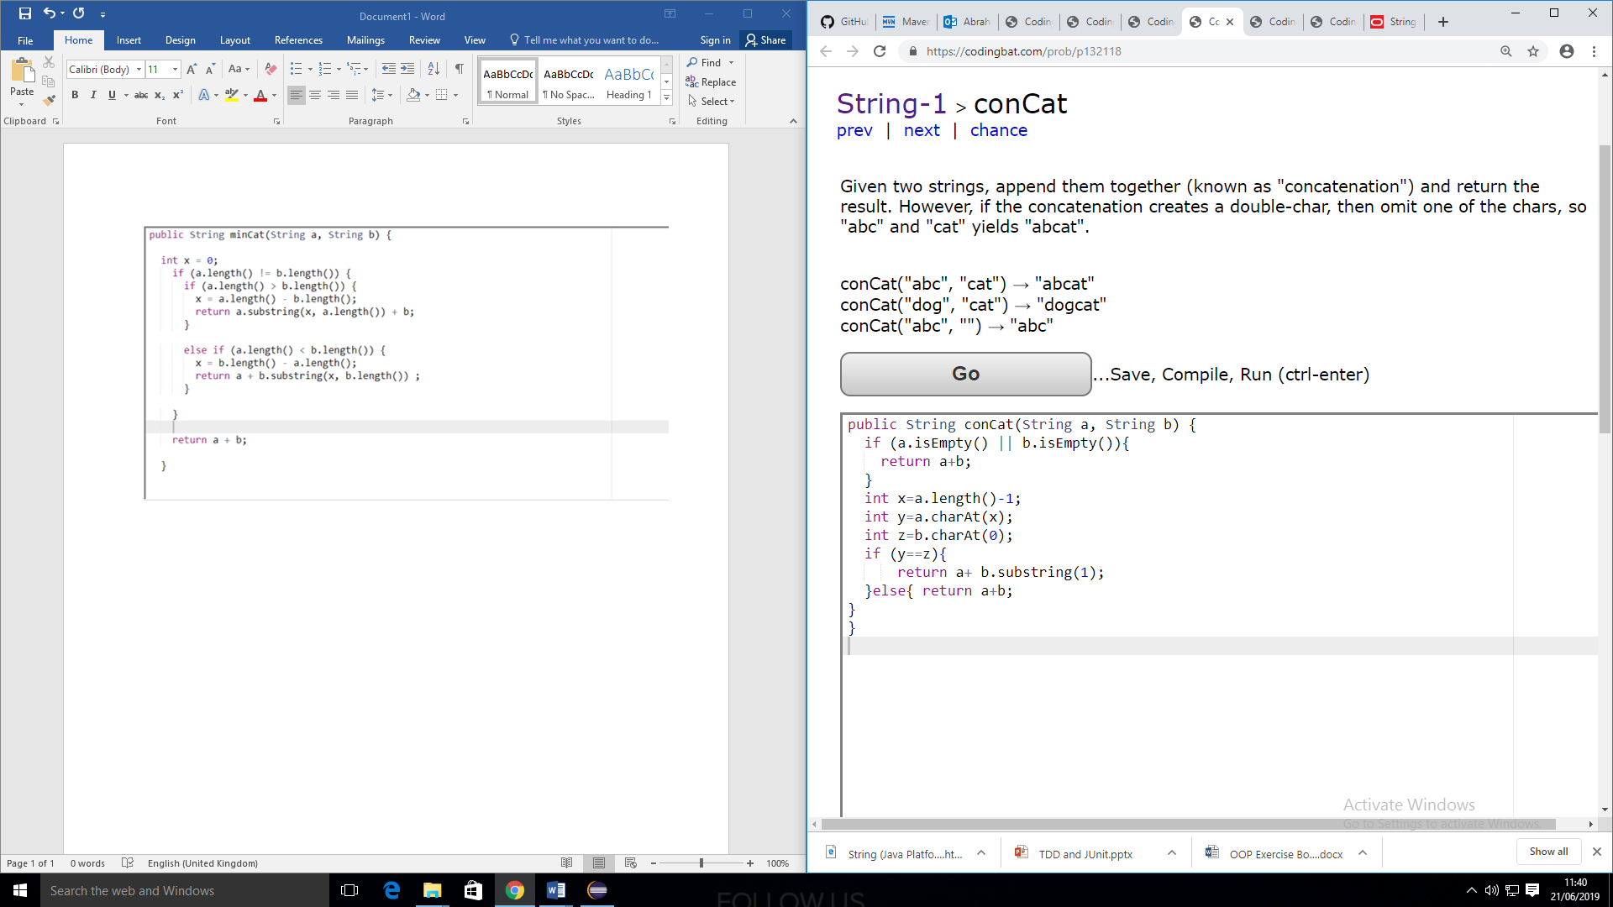

Returns strings beginning red or blue, empty if neither

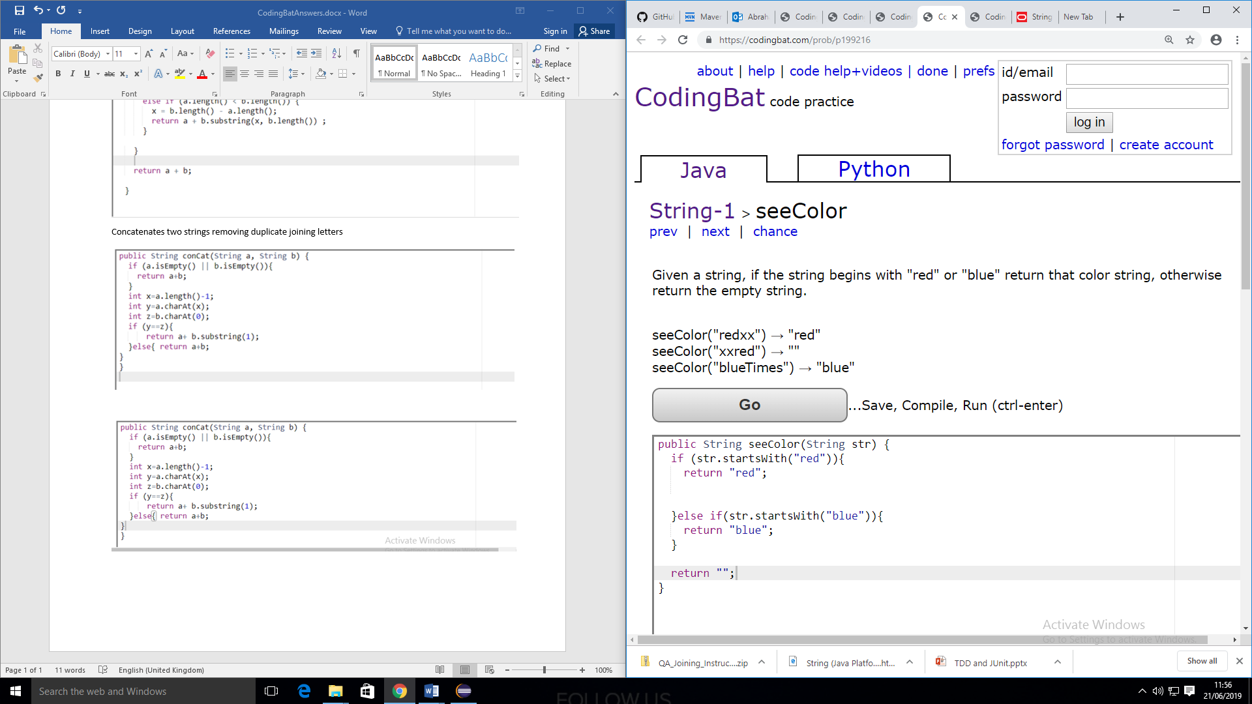

**String Manipulation**

a.startswith”red”

a.endswith”red”

a.charAt(0);

s=s.substring(2,4);

s=s.substring(1); // letter 1 onwards

s.split(“ ”)

a.length()